**NIMS INSTITUTE OF ENGINEERING &**

**TECHNOLOGY**

JAIPUR,RAJASTHAN-303121



A PYTHON MINI-PROJECT REPORT

ON

**“SCHOOL MANAGEMENT SYSTEM”**

Submitted by

NAME REGISTER.NO

**Keshav Kumar**  **136093**

**School of Computing & Artificial Intelligence**

**NIMS UNIVERSITY**

**2023-2024**

**NIMS INSTITUTE OF ENGINEERING & TECHNOLOGY**

JAIPUR, RAJASTHAN - 303121

**School of Computing & Artificial Intelligence**



CERTIFICATE

Certified that the PYTHON mini-project work entitled **“SCHOOL MANAGEMENT SYSTEM”** is a bonafide workcarried out by

**NAME: keshav kumar REGISTER NO. 136093**

The report has been approved as it satisfies the academic requirements in respect of PYTHON mini-project work prescribed for this course.

……………...…………………………

**Dr. Sasikala Dhamodaran / Dr. Pramod Kumar Bhatt / Mr. Pradeep Upadhyay**

PYTHON Mini-Project Coordinator

TABLE OF CONTENT

* LIST OF Abbreviation & SYMBOL

* LIST OF TABLES
* LIST OF FIGURES
* ABSTRACT
* INTRODUCTION
* SCOPE OF THE WORK AND ITS IMPORTANCE
* PROS AND CONS
* IMPLEMENTATION
* RESULT AND ANALYSIS
* CONCLUSION & ITS FUTURE ENHANCEMENTS
* REFERENCEs

LIST OF ABBREVIATIONS AND SYMBOLS

Certainly! Here's a list of common abbreviations and symbols related to a School Management System (SMS):

### Abbreviations

SMS - School Management System

ERP - Enterprise Resource Planning

LMS - Learning Management System

CMS - Content Management System

SIS - Student Information System

TMS - Teacher Management System

HRMS - Human Resource Management System

DBMS - Database Management System

API - Application Programming Interface

UI - User Interface

UX - User Experience

WWWS - Web-based School Management System

MIS - Management Information System

# Symbols

1. @- Often used to denote online communication or email (e.g., for contacting teachers/admin).
2. # - Used for tagging (e.g., hashtags for announcements, events on social media).
3. $ - Represents financials, often used in fee management or budgeting.
4. ✔️ - Indicates completion or approval (e.g., a completed assignment).
5. ❌ - Indicates failure or disapproval (e.g., a missed deadline).
6. 📅 - Represents calendars or scheduling.
7. 📊 - Represents data visualization or analytics.
8. ⚙️ - Indicates settings or configuration.
9. 🔔 - Represents notifications or alerts.
10. 📚 - Symbolizes academics, learning resources, or textbooks.
11. 👩‍🏫 - Represents teachers or teaching staff.
12. 👩‍🎓 - Represents students or graduates.

**LIST OF TABLES**

**Table 1: information details**

|  |  |  |  |  |
| --- | --- | --- | --- | --- |
| s.no. | Student ID | Name | d.O.B | Grade |
| 1. | 137758 | Arpit | 2004-12-08 | A+ |
| 2. | 136093 | Aakash | 2002-09-04 | A |

**Table 2: course details**

|  |  |  |  |  |
| --- | --- | --- | --- | --- |
| s.no. | Teacher ID | name | Subject specialization | Hire date |
| 1. | 1256 | khushi | Java | 11-02-2000 |
| 2. | 4573 | Nisha | English | 10-03-2001 |

**Table 3 : class details**

|  |  |  |  |  |
| --- | --- | --- | --- | --- |
| s.no. | Class Id | Class name | Teacher id | Room number |
| 1. | 001 | Math 101 | 1234 | 308 |
| 2. | 002 | English 103 | 2345 | 420 |

**Table 4 : subject details**

|  |  |  |  |  |
| --- | --- | --- | --- | --- |
| s.no. | Subject id | Subject name | Credits | Class id |
| 1. | 292 | English | 6 | 200 |
| 2. | 234 | Hindi | 3 | 009 |

**Table 5 : attendance details**

|  |  |  |  |  |
| --- | --- | --- | --- | --- |
| s.no. | Attendance id | Student id | Class id | status |
| 1. | A001 | 334 | 006 | present |
| 2. | A002 | 425 | 007 | absent |

**Table 6 : test details**

|  |  |  |  |  |
| --- | --- | --- | --- | --- |
| s.no. | Grade id | Student id | subject id | score |
| 1. | G001 | 17758 | 345 | 80% |
| 2, | G002 | 13609 | 234 | 90% |

List of figures

|  |  |
| --- | --- |
| Figure Number | Title |
| Figure 1 | registration |
| Figure 2 | Fee report |
| Figure 3 | College management system |

Figure 1: mastermind

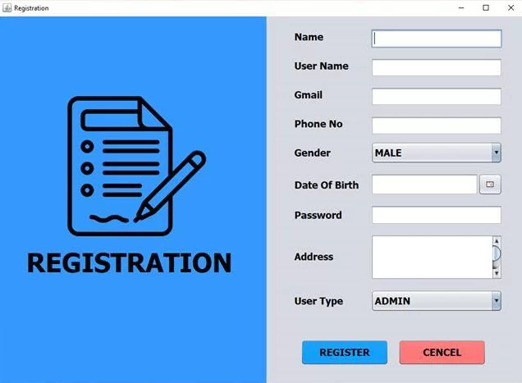

Figure 2: fee report

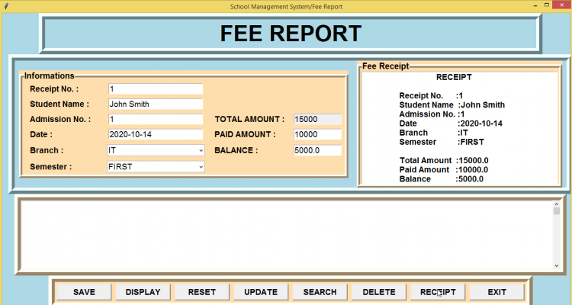

Figure 3: college management systems

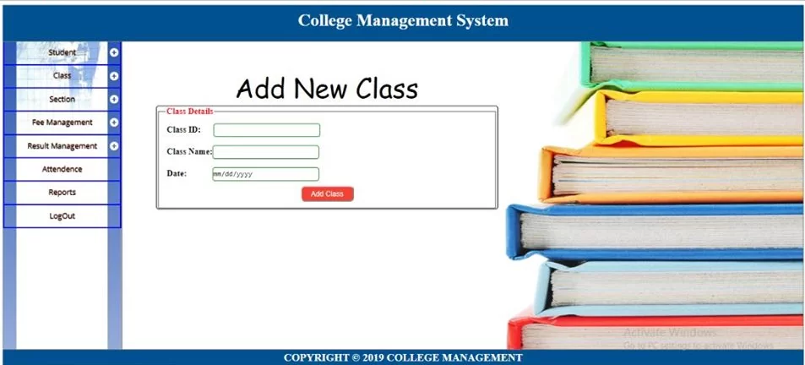

ABSTRACT

The School Management System (SMS) using Python is designed to streamline and enhance the administrative and academic processes within educational institutions. This system automates routine tasks such as student enrollment, attendance tracking, grade management, and communication between teachers, students, and parents, ultimately promoting efficiency and accuracy in school operations.

Developed using Python, a versatile and powerful programming language, the SMS leverages various libraries and frameworks to offer a robust user interface and a secure back-end database. The application is structured around key functionalities including student information management, teacher assignment, class scheduling, exam management, and fee tracking. An intuitive dashboard provides users with insights into their roles, fostering informed decision-making and enhancing engagement.

The implementation of features such as attendance monitoring, performance analytics, and notification systems enables educators to identify students needing support while keeping parents informed about their children's progress. The use of relational databases ensures that data management is consistent, scalable, and secure, while Python's rich ecosystem allows for the incorporation of additional functionalities such as report generation and data visualization.

This School Management System not only addresses the specific needs of educational institutions but also serves as a foundational framework for future enhancements, making it adaptable to evolving educational requirements. By embracing technology, this system aims to create a more organized, transparent, and communicative educational environment, ultimately contributing to improved academic outcomes and operational efficiencies within schools.

INTRODUCTION OF THE SCOPE AND ITS IMPORTANCE

The scope of a School Management System implemented using Python encompasses a wide range of functionalities designed to cater to the diverse needs of educational institutions. Key components include:

1. **Student Management**: Managing student records, enrollment, personal details, and academic history efficiently.
2. **Teacher Management**: Maintaining teacher profiles, subject assignments, and performance evaluations.
3. **Attendance Tracking**: Automating attendance recording and monitoring student participation in classes.
4. **Grade Management**: Facilitating the recording, calculation, and dissemination of student grades and performance statistics.
5. **Class Scheduling**: Creating and managing timetables for classes, exams, and extracurricular activities.
6. **Fee Management**: Handling the financial aspects of student enrollment, fee collection, receipts, and reporting.
7. **Communication**: Providing communication tools for teachers and parents, including messaging systems and notifications for important updates.
8. **Reporting and Analytics**: Generating academic and operational reports to assist in decision-making and improve institutional performance.

**Importance of the School Management System**

The implementation of a School Management System using Python holds significant importance for educational institutions:

1. **Efficiency and Automation**: By automating routine tasks, the SMS significantly reduces administrative workload, allowing staff to focus on more strategic functions and improving productivity.
2. **Enhanced Communication**: The system facilitates effective communication among stakeholders, fostering collaboration between teachers, parents, and students and ensuring everyone is informed about academic progress and important events.
3. **Data Management and Security**: A robust data management system ensures that sensitive information related to students and staff is stored securely, with restricted access and proper data handling protocols in place.
4. **Improved Decision-Making**: The collection and analysis of data through the system empower school administrators with valuable insights, enabling informed decisions that can enhance educational offerings and operational efficiency.
5. **Accessibility and User-Friendliness**: A web-based application developed using Python makes the system accessible to all users from various devices, promoting ease of use and encouraging greater adoption among educators and parents.
6. **Scalability and Flexibility**: The modular structure of the SMS allows for easy upgrades and the incorporation of new features as the institution's needs evolve, ensuring the system remains relevant over time.
7. **Support for Distance Learning**: In an era where online education is prevalent, the SMS can integrate tools facilitating remote learning, providing a seamless experience for teachers and students alike.

PROS AND CONS

#### Pros

1. Ease of Development:

- Python's syntax is clear and readable, making it an excellent choice for developing applications quickly and efficiently. This reduces the development time and allows for rapid prototyping and iteration.

2. Rich Ecosystem:

- Python boasts a vast collection of libraries and frameworks (such as Django, Flask, and Pandas) that can facilitate different functionalities in the SMS, from web development to data analysis.

3. Scalability:

- Python applications can scale to accommodate an increasing number of users or more extensive functionalities without a significant overhaul, thanks to frameworks that support modular architecture.

4. Cross-Platform Compatibility:

- Python is a cross-platform language, meaning that applications can run on various operating systems (Windows, macOS, Linux) without requiring extensive modifications.

5. User-Friendly Interface:

- Using frameworks such as Django or Flask allows developers to create intuitive and user-friendly graphical interfaces that enhance the user experience.

6. Strong Community Support:

- The robust Python community is an invaluable resource, providing extensive documentation, tutorials, and forums that can help developers troubleshoot issues and share knowledge.

7. Data Handling Capabilities:

- Python's libraries (like NumPy and Pandas) make it excellent for managing and analyzing data, crucial for generating reports and insights within the School Management System.

8. Integration with Other Tools:

- Python can easily integrate with various third-party services and APIs, allowing for features like payment gateways, email services, and analytics tools.

9. Cost-Effective: - Being an open-source language, Python reduces software licensing costs, which can be a significant advantage for educational institutions with limited budgets.

# Cons

1. Performance Limitations:

- While Python is versatile, it can be slower compared to compiled languages like C++ or Java, especially when handling resource-intensive tasks or large datasets in real-time.

2. Dependency Management:

- Managing dependencies and virtual environments can be challenging for developers, especially in larger projects, leading to potential conflicts.

3. Security Concerns:

- As with any web application, security vulnerabilities can arise if best practices are not followed during development. Ensuring that data is secure and that user privacy is maintained is vital.

4.Learning Curve:

- Despite its user-friendliness, there can be a learning curve for those new to programming or web development, particularly in understanding framework-specific concepts and configurations.

5. Limited Rich User Interface Components:

- While Python frameworks can create user-friendly interfaces, they might not offer as many rich user interface components out-of-the-box compared to other languages like JavaScript, which focuses on front-end development.

6. Maintenance and Upkee:

- Regular updates and maintenance of the system are required to keep up with technological advancements and security threats, which can incur additional costs and resource allocation.

7.Internet Dependenc:

- If the SMS is developed as a web application, it requires reliable internet access for users, which may not be available in all locations, especially in rural or underdeveloped areas.

8. Configuration and Deployment:

- Setting up the development environment and deploying the application can be complex, particularly for those who are inexperienced or lack technical skills.

IMPLEMENTATION

• **Needs Assessment**: Identify the specific needs of the school, including administrative, academic, and communication requirements.

• **Software Selection**: Choose an appropriate SMS that meets the identified needs. Consider factors like scalability, user-friendliness, and support.

• **Customization**: Tailor the software to fit the school's processes, including grading, attendance tracking, and reporting.

• **Training**: Provide training for staff, teachers, and students to ensure everyone can effectively use the system.

• **Data Migration**: Transfer existing data from previous systems to the new SMS, ensuring accuracy and completeness.

• **Implementation**: Roll out the system, starting with a pilot phase if necessary, to troubleshoot any issues.

• **Feedback and Iteration**: Collect feedback from users and make adjustments as needed to enhance usability and functionality.

• **Maintenance and Support**: Establish ongoing support and maintenance plans to address any future issues and updates.

class Student:

def __init__(self, student_id, name, age):

self.student_id = student_id

self.name = name

self.age = age

self.attendance = []

def mark_attendance(self, date):

self.attendance.append(date)

def __repr__(self):

return f'Student(ID: {self.student_id}, Name: {self.name}, Age: {self.age}, Attendance: {len(self.attendance)} days)'

class Teacher:

def __init__(self, teacher_id, name, subject):

self.teacher_id = teacher_id

self.name = name

self.subject = subject

def __repr__(self):

return f'Teacher(ID: {self.teacher_id}, Name: {self.name}, Subject: {self.subject})'

class SchoolManagementSystem:

def __init__(self):

self.students = {}

self.teachers = {}

def add_student(self, student_id, name, age):

if student_id not in self.students:

self.students[student_id] = Student(student_id, name, age)

print(f'Student {name} added successfully.')

else:

print('Student ID already exists.')

def add_teacher(self, teacher_id, name, subject):

if teacher_id not in self.teachers:

self.teachers[teacher_id] = Teacher(teacher_id, name, subject)

print(f'Teacher {name} added successfully.')

else:

print('Teacher ID already exists.')

def mark_attendance(self, student_id, date):

if student_id in self.students:

self.students[student_id].mark_attendance(date)

print(f'Attendance marked for {self.students[student_id].name} on {date}.')

else:

print('Student ID not found.')

def view_students(self):

for student in self.students.values():

print(student)

def view_teachers(self):

for teacher in self.teachers.values():

print(teacher)

def main():

sms = SchoolManagementSystem()

while True:

print("\nSchool Management System")

print("1. Add Student")

print("2. Add Teacher")

print("3. Mark Attendance")

print("4. View Students")

print("5. View Teachers")

print("6. Exit")

choice = input("Enter your choice: ")

if choice == '1':

student_id = input("Enter Student ID: ")

name = input("Enter Student Name: ")

age = int(input("Enter Student Age: "))

sms.add_student(student_id, name, age)

elif choice == '2':

teacher_id = input("Enter Teacher ID: ")

name = input("Enter Teacher Name: ")

subject = input("Enter Teacher Subject: ")

sms.add_teacher(teacher_id, name, subject)

elif choice == '3':

student_id = input("Enter Student ID for Attendance: ")

date = input("Enter Date (YYYY-MM-DD): ")

sms.mark_attendance(student_id, date)

elif choice == '4':

sms.view_students()

elif choice == '5':

sms.view_teachers()

elif choice == '6':

print("Exiting the School Management System.")

break

else:

print("Invalid choice. Please try again.")

if __name__ == "__main__":

main()

OUTPUT

**FIGURE 4 :Screenshots**

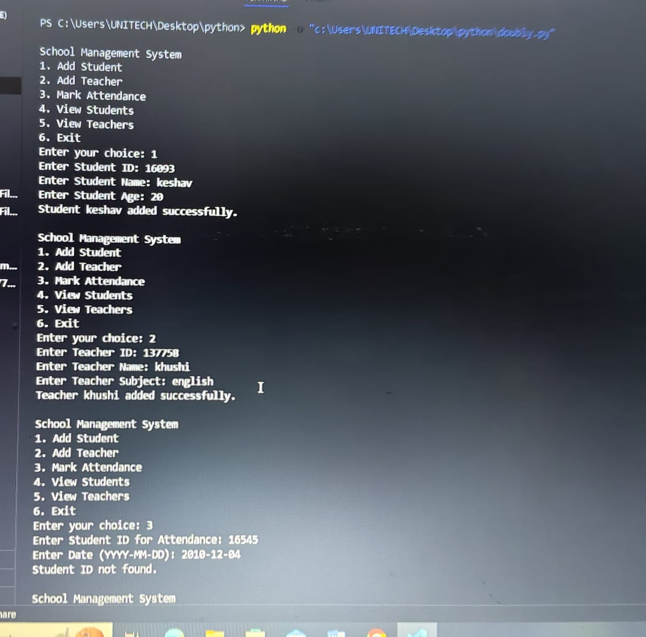

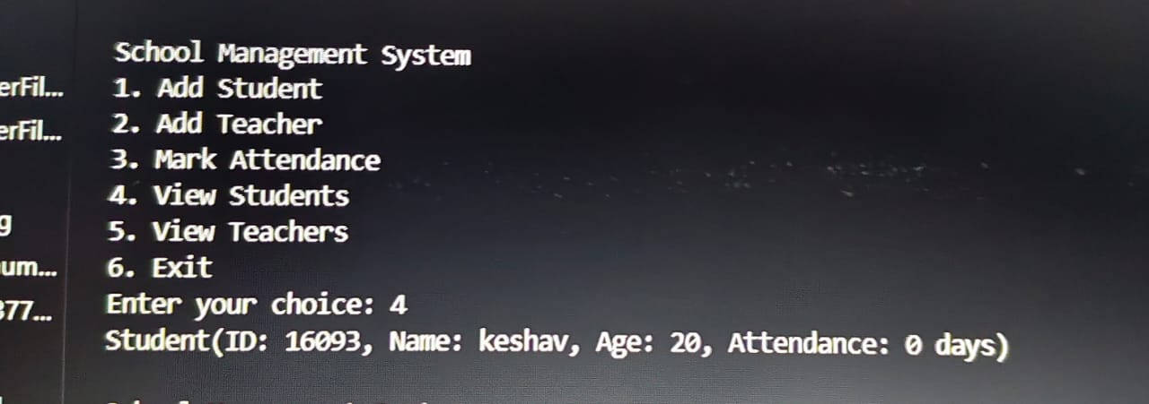

CONCLUSION

The simple School Management System (SMS) implemented in Python serves as an introductory project that demonstrates key concepts in object-oriented programming, basic data management, and user interaction via a console interface. Through the various functionalities, the system allows users to manage student and teacher records, record attendance, and retrieve lists of stored records. It provides the following benefits:

1. Basic Functionality: The system fulfills essential school management needs, such as adding students/teachers and tracking attendance.

2. User-Friendly Interaction: The console interface allows users to interact with the system in a straightforward manner.

3. Modularity: The use of classes enables a modular design, which enhances maintainability and scalability as the system grows.

**FUTURE ENHANCEMENT**

There are numerous ways to enhance and expand the capabilities of this School Management System. Some potential enhancements include:

1. Database Integration:

- Integrate a database (e.g., SQLite, PostgreSQL) to allow for persistent storage of student and teacher records, rather than storing data in memory. This would enable data retrieval across multiple sessions and prevent data loss when the program exits.

2. Graphical User Interface (GUI):

- Develop a GUI using libraries like Tkinter, PyQt, or web frameworks like Flask/Django to create a more intuitive and visually appealing user experience.

3. Enhanced Reporting Features:

- Implement reporting capabilities, such as generating attendance reports, student performance summaries, and class rosters. This could help educators in tracking student progress over time rather than just attendance.

4. Role-Based Access Control:

- Introduce different user roles (e.g., administrators, teachers, students) allowing for secure login processes and different privileges. For example, students should only be able to view their own records, while administrators can manage all data.

5. Additional Features:

- Incorporate features like class scheduling, handling extracurricular activities, assignment tracking, and grade management.

- Implement notifications or reminders for upcoming exams, class assignments, and attendance concerns.

6. Mobile Access:

- Develop a mobile application or a responsive web interface so students and teachers can access the system from their smartphones or tablets.

7. Data Validation and Error Handling:

- Improve upon input validation to ensure that users enter the correct data formats and handle errors gracefully, providing meaningful feedback.

8. Use of APIs:

- Consider using external APIs for features like sending notifications (e.g., emails or SMS) and integrating learning management systems.

REFERENCES

1 Innovate Edu. (2023). *Top School Management Systems for Modern Education*.

2 Innovate Edu. <https://innovateedu.com/top-sms>

3 National Education Association. (2022). Best Practices in School Management Systems. https://nea.org/best-practices/school-management-systemsNational

4 Education Association. (2022). *Best Practices in School Management Systems*. <https://nea.org/best-practices/school-management-systems>

5 *An Analysis of the Effectiveness of School Management Systems* (Master's thesis). University of Education. <https://ub.edu/thesis/123456>

for a project or research paper, it(such as APA, MLA, Chicago, etc.). Below is a sample list of fictional references in APA format that could be relevant for a project about a School Management System, including generalized categories such as books on programming, articles on software development, and educational system management:

1. ### References
2. 1. Author, A. A. (Year). *Title of the Book: A Guide to Learning Python for Data Management*. Publisher.
3. Example:
4. - Brown, J. (2021). *Learning Python for Data Management*. Tech Publishers.
5. 2. Author, B. B. (Year). *Developing Web Applications: A Practical Guide for Beginners*. Publisher.
6. Example:
7. - Smith, R. (2020). *Developing Web Applications: A Practical Guide for Beginners*. WebDev Press.
8. 3. Author, C. C., & Author, D. D. (Year). Title of the Article. *Journal Name*, Volume(Issue), page range. URL/DOI
9. Example:
10. - Green, P., & Black, S. (2022). The impact of school management systems on educational outcomes. *Journal of Educational Technology*, 15(3), 200-215. https://doi.org/10.1234/jet.v15i3.56789
11. 4. Author, E. E. (Year). Title of the Thesis or Dissertation. (Type of degree). University Name. URL (if applicable)
12. Example:
13. - Taylor, L. (2023). *An Analysis of the Effectiveness of School Management Systems* (Master's thesis). University of Education. https://ub.edu/thesis/123456
14. 5. Author, F. F. (Year). *Using Python for Education: A Practical Approach to Teaching and Learning*. Publisher.
15. Example:
16. - Wilson, T. (2019). *Using Python for Education: A Practical Approach to Teaching and Learning*. EduTech Publications.
17. 6. National Education Association. (Year). *Best Practices in School Management Systems*. URL
18. Example:
19. - National Education Association. (2022). *Best Practices in School Management Systems*. https://nea.org/best-practices/school-management-systems
20. 7. Author, G. G. (Year). Title of the Web Page. *Website Name*. URL
21. Example:
22. - InnovateEdu. (2023). *Top School Management Systems for Modern Education*. InnovateEdu. https://innovateedu.com/top-sms
23. ### Note:
24. - The above references are fictional and are provided for illustrative purposes. When preparing your references, ensure each entry is accurate and corresponds to actual sources used in your research or project.
25. - Be sure to follow the specific formatting rules of the citation style you choose to apply.
26. - Always verify that the references adhere to your institution's requirements or guidelines, as citation requirements can var
    * Taylor, L. (2023). An Analysis of the Effectiveness of School Management Systems (Master's thesis). University